Total 228.5-160+190=258.5

10 euro on keane to get booked- Lost 10

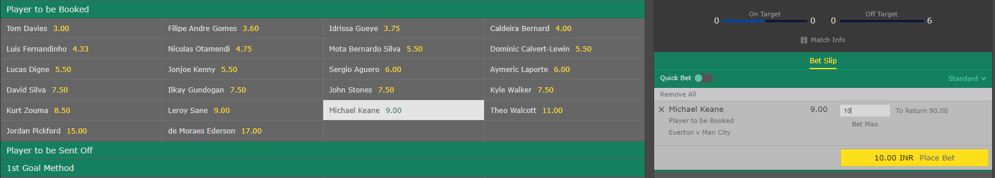

100 euros on under 12 corners

Won 130

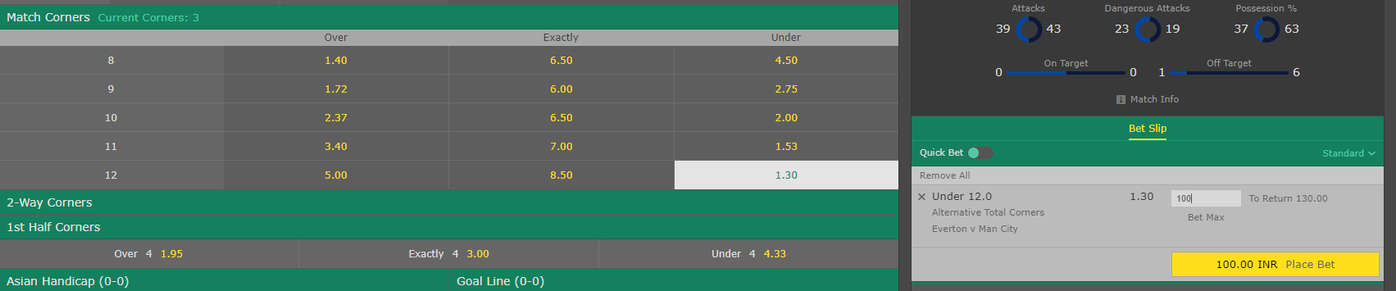

50 euros on “no cards in 50-60 min

Won 70 euros

